**MOTHERCARE PREPARATORY SCHOOLS.**

**P.3 SCIENCE LESSON NOTES FOR TERM II 2019**

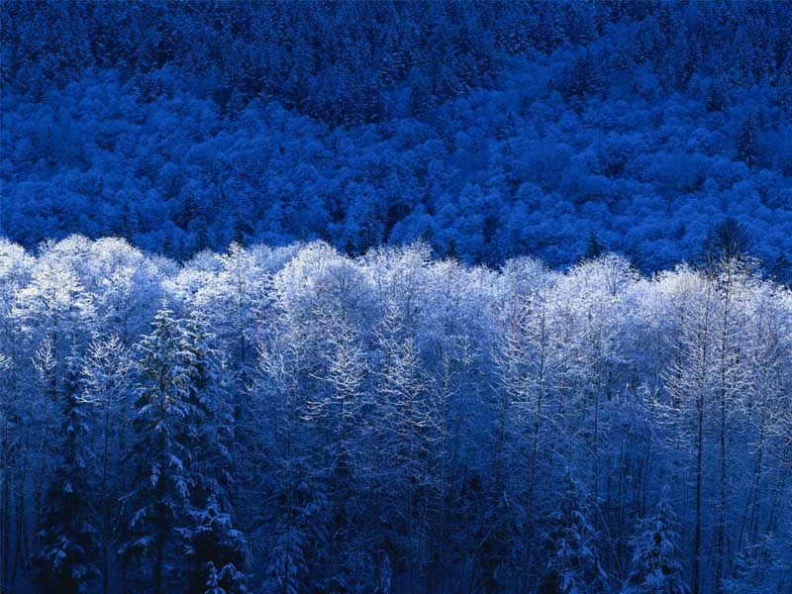

**THEME: LIVING THINGS IN OUR SUBCOUNTY**

Reading descriptions of words

Breathe

Wastes

Respond

Reproduce

Feed

Stimuli

Thorax

Spiracles

Antennae

Tasting

Laying

Feathers

Beaks

Swimming

Gills

Cold blooded

Hooves

Buttons

Manure

Prestige

Dowry

Buffalos

Tourists

Taboos

Giraffes

Wetland

Water logged

Crocodiles

Tortoises

Earthworms

Hides

Aquatic animals

A pond

Protection

Monitor

Shelter

Slugs

Friendship

Wriggling

Gliding

Maggot

Nostril

Ventral fin

Caudal fin

Pectoral fin

Dorsal fin

Corners

Senses

Nile perch

Silver fish

Proteins

Belts

Salting

Refrigerator

Scratching

Warmth

Flightless

Web feet

Penguins

Geese

Swans

Poultry

Pigeons

Sucking

Regarded

Scorpions

Harmful

Spoil

Weevils

Wax

Swarm

Proboscis

Nectar

Dragonflies

**THEME: LIVING THINGS IN OUR SUBCOUNTY**

***LESSON TEN***

**What are living things?**

Living things are things which have life.

**Characteristics of living things**

* They breathe/respire.
* They feed.
* They move/locomote.
* They reproduce.
* They excrete(pass out wastes)
* They respond to stimuli
* They grow and change

Examples: cows , goats , oranges , mangoes , beans , etc

**Non-living things:**

These are things which do not have life.

e.g stones, soil, water , timber , etc.

**Characteristics of non-living things**

* They do not breathe
* They do not feed.
* They do not move
* They do not reproduce
* They do not excrete( pass out wastes)
* They do not respond to stimuli
* They do not grow and change.

***Activity***

1. What are living things?

………………………………………………………………………………………………………………………..

2. State any two characteristics of living things.

i……………………………………………………………………………………………………………………….

ii………………………………………………………………………………………………………………………

3.Name two examples of living things.

i……………………………………………………..ii…………………………..…………………………………

5.What are non-living things?

……………………………………………………………………………………………………………………….

4.Give two characteristics of non-living things.

i……………………………………………………………………………………………………………………..

ii………………………………………………………………………………………………………………………..

***LESSON ELEVEN***

**Groups of living things.**

Living things are divided into two groups ;

1. plants
2. Animals.

Types of animals in our division

There are two types of animals in our sub county and these are;

1. Domestic animals
2. Wild animals

**Domestic animals:**

Domestic animals are animals kept at home.

Examples;

* Cows
* Dogs
* Goats
* pigs
* Sheep
* Rabbits
* Donkeys

**Wild animals**

* Wild animals are animals which live in the bush /zoo/forest.

**Examples:**

* Antelopes
* lion
* Giraffes
* Elephants
* Buffalos
* Zebras
* Leopards

**Activity**

1. What are domestic animals?

……………………………………………………………………………………………………………

1. List down two examples of domestic animals.

i…………………………………………………………ii……………………………………………..

1. What are wild animals?

……………………………………………………………………………………………………………….

1. Name two animals found in the zoo

i…………………………………………………………….ii………………………………………………

***LESSON TWELVE***

**Uses of animals**

* Domestic animals give us food, manure, skins, roofs, wool.
* Some animals provide transport and work e.g. horse, camel, donkey, etc.
* Some animals are used for protection e.g. dogs.
* Some wild animals attract tourists.
* Some wild animals act as taboos for some clans.

**Dangers of wild animals**

* Some wild animals can eat people e.g. lions, leopards, etc.
* Some wild animals can Animals **in a school compound** also eat domestic animals.

In the school compound, there are both domestic and wild animals.

**Examples:**

* snakes
* lizards,
* snails
* rabbits
* goat
* rats
* grasshoppers
* locusts
* geckos

Note: Draw animals that live in a school compound.

**Animals in the garden**

* There are animals which live in the school garden as their habitat.

***Examples***: weaverbirds, earthworms, snakes, rats, squirrels

Also there are insects which live in the garden. E.g. butterflies, bees, beetles, termites, etc.

***Note***: Draw some animals found in the garden.

**Animals in the forest.**

In the forest we find their animals like lion, monkeys, foxes, elephants, buffalos, leopards, etc.

**Animals in swamps and in water:**

* A swamp is a water logged area with some plants in it or
* A swamp is a wetland with vegetation in it.
* A swamp can be called a wetland.

**Examples of animals which live in a swamp**

* Some snakes
* Snails
* Earthworms
* Slugs
* Crocodiles
* Monitor lizards
* Mud fish

**Water animals**

Animals that live in water are called aquatic animals.

**Examples**

* Fish
* Crocodiles
* Hippopotamus
* Frogs
* Slugs
* Crab

**A POND**

A pond is a small pool of water.

Some ponds are natural and others are manmade.

A pond can be found in homes, schools and hotels.

**Examples of animals in a pond**

* Fish
* Frogs
* Slugs
* Snails

**AN AQUARIUM**

An aquarium is a glass tank where fish and other water animals are kept in our homes.

Places where an aquarium can be found:

* Hotels
* School compounds,
* homes, etc.

Animal movements

|  |  |
| --- | --- |
| Way of movement | Animals |
| Crawling | Lizards  Chameleon  Tortoise |
| Hopping | Frogs  Grasshoppers  Locusts  Toads |
| Flying | Butterflies  Houseflies  Bees |
| Walking | Cows  Dogs  Hens  Man |
| Gliding | Snail  Slug  Snake |
| Wriggling | Caterpillar  Earthworms  Maggot |
| Swimming | Fish  Ducks  Swans  Geese |

Why animals move from one place to another

* To get food
* To get water
* To get protection
* To get shelter
* To look for their young ones
* To look for friendship
* To look for new homes

**External parts of a fish.**

g f e

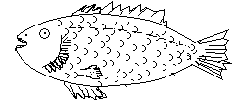

H

i

k a b a c

1. Pelvic fin
2. Pectoral fin
3. Ventral/anal fin
4. Tail/caudal fin
5. Dorsal fin
6. Lateral line
7. Nostril
8. Mouth
9. Eye
10. Scale
11. Gill cover/operculum
12. Anus

**USES OF PARTS OF A FISH**

1. The dorsal fin protects the fish from enemies.
2. The eyes are used for seeing.
3. The gill cover protects the gills.
4. The tail fin helps the fish to turn to different directions.
5. The scales protect the body of a fish.
6. The nostrils are for smelling.
7. The mouth is for feeding /getting food.
8. The lateral line detects sound waves.
9. Pectoral and pelvic fins are used for breaking speed and going up or down wards in water.
10. Gills are used for breathing.

**Examples of fish common in Uganda.**

* Tilapia (engage)
* Nile perch (empuuta)
* Cat fish
* Silver fish (mukene)
* Lung fish
* Mud fish

**Use of fish**

* Source of proteins
* Scales are used to make bags and belts.
* Fish helps to control mosquito larvae.
* Helps in manufacture of animal feeds
* Some people get jobs e.g fish mongers
* For selling

**Methods of catching fish**

* fish hooks
* Fishing nets
* Fishing baskets

**FISH PRESERVATIONS**

**Preservation**

Preservation is the way of keeping fish for a long time without going bad.

Fish preservation is the keeping of Fish free from germs.

**Ways or preserving fish**

* By smoking
* By refrigeration
* By salting
* By sun drying
* By tinning/canning

**SUB THEME BIRDS**

ON A FIRM FOUNDATION WE BUILD.

**The external parts of a bird.**

a b



i

l

d

c

g

e

1. Comb/crown
2. Eye
3. Wing
4. Tail feathers
5. Spur
6. Claws/nails
7. Leg
8. Wattle
9. Beak

**Functions of parts of a bird.**

Beak - It picks food from the ground (feeding)

- It is used for protection

Legs -For walking

Claws -For protection

-for protection

Spur -for fighting/ protection

Eyes -for seeing

Wing -for flying

-giving birds shape

-cover body of a bird.

-give birds colour

Feathers -give birds warmth

**Characteristics of birds.**

* Most birds fly
* Most birds are covered with feathers.
* Have beaks
* Have claws
* Reproduce by laying eggs

***Note***: Swimming birds have web feet which help them to swim on water.

**Examples of swimming birds**

* Ducks
* Geese
* Swans

**Types of birds**

* Domestic birds
* Wild birds

**Domestic birds**

* Are birds kept in our homes.
* They are also called poultry.

**E*x*amples**

* Ducks
* Pigeons
* Peacocks
* Guinea fowls
* Chicken
* Parrots
* Turkeys

***Wild birds***.

* Are birds found in the bush.

***Examples***

* Weaverbirds
* Kites
* Crested cranes
* Eagles/crows

**Habitats of birds**

* A habitat is a home of a living thing.
* Birds live on trees, nests, burrows.

**Uses of birds to people;**

* Birds provide meat e.g. chicken, turkey
* Provide manure
* Provide feathers
* Provide bones used to make animal feeds
* Used f or cultural purposes e.g. paying dowry
* Used for tourist attraction

**Parts of an insect**

b

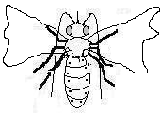

a

i

h

g

1. Feelers/antennae
2. Proboscis
3. Eye
4. Wing
5. Leg
6. Spiracles
7. Abdomen
8. Thorax
9. Head

The three main body parts of an insect

1. Head - It is where the eyes, feelers and proboscis are found.
2. Thorax - It’s where the legs and wings are attached.
3. Abdomen It is where we find the spiracles.

**Functions of parts of an insect**

1. Feelers - for feeling
2. Proboscis - used for sucking food and water
3. Wing - for flying
4. Spiracles - for breathing

**Characteristics of insects**

* Insects have three main body parts
* Have three pairs of legs
* Have jointed legs
* Have feelers for feeling and smelling

***Note***: spiders, ticks and mites have two main body parts and eight legs. They are not insects.

**Harmful and useful insects**

* Some insects are harmful or dangerous to man

**Examples**:

* Wasps
* Mosquitoes
* Termites
* Bees
* Houseflies
* Red ants
* Cockroaches

**Useful insects to man**

* Bees
* Grasshoppers
* White ants

**INSECT HABITATS (HOMES)**

**Insects that live in the soil**

* Termites
* White ants
* Red ants

**Insects that live on plants**

* Butterflies
* Caterpillars

**Social and solitary insects**

Social insects are the insects that live , move and work together.

**Examples**

* Bees
* Red ants
* Termites
* Wasps
* Black ants
* White ants

Anti – social insects

* Are insects which do not live, move ad work together.

**Examples**

* Houseflies
* Locusts
* Mosquitoes
* Cockroaches
* Dragon flies
* Butterflies

**Other insect’s habitats.**

* Bees - bee hive
* Spider - web

**CARE FOR INSECTS, BIRDS AND ANIMALS**

**Care for bees**

* By providing a hive
* By planting flowers for nectar
* By providing water.

**Types of bees.**

* Worker bees
* Drone bees
* The queen bees

***Note***: a group of bees is called a swarm.

**Uses of bees to man**

* Bees provide honey
* Bees provide bee wax
* Young bees are eaten

**Importance of honey**

* Honey is used as medicine e.g. syrup
* Honey is used to make some foods sweet
* People sell honey and get money
* It is a source of carbohydrates

**Products from the wax**

* Candles
* Shoe polish
* Some cosmetics
* After shave

**Ways of caring f or birds.**

* Treating birds
* Keeping bird’s records
* Providing food to birds
* Building birds’ houses
* Vaccinating birds
* Protecting eggs

**Signs of a sick bird**

* It is sleepy
* Has dull feathers
* It does not want to eat food.

**Caring f or birds and animals**

* Avoid bush burning
* Avoid cutting down trees
* Avoid poaching

***Note***: Poaching is the hunting of wild animals without permission

* Treating sick animals in the wild life centre
* Providing food to animals.

**SUB THEME: PLANTS**

**Reading description of words.**

* Seed
* Develop
* Germination
* Seedling
* Condition
* Necessary
* Moisture
* Temperature
* Warmth
* Epigeal
* Hypogeal
* Cotyledon
* Dicots
* Monocots
* Thatching
* Chlorophyll
* Upright/erect
* Clasping
* Underground
* Flower
* Habitat
* Nursery bed
* Harsh
* Weeding
* Spraying
* Chemicals
* Thinning
* Transplanting
* Mulching
* Fencing
* Rotation
* Photosynthesis
* Legumes
* Cereals
* Firmly
* Reproductive
* Suffocate
* Harbor
* Excess
* Pests
* Pesticides
* Premature
* Pruning
* Transplanting
* t
* Manure

Plants are anything on earth’s surface

**GROUPS OF PLANTS**

1. Flowering plants

Are plants which bear flowers e.g. maize, beans, grass, tomatoes, peas, etc.

1. Non-flowering plants

Are plants which do not bear flowers e.g. Ferns, conifers, mosses, liver worts

**Characteristics of plants**

They grow, reproduce, feed, breathe, and excrete.

**Plants habitats**

Plant habitat is a place here plants grow or are found

N.B a habitat is a home of a living thing.

**Plants in school compounds.**

* Pawpaw
* Avocadoes
* Mangoes
* Palms
* Trees, flowers, etc.

**Plants in swamps**

* Papyrus
* Yams
* Rice
* Sugarcanes, etc.

Plants in desert/dry areas

Plants that grow on rocks

* Lichens
* Liverworts
* Ferns
* Conifers
* Mosses

**SCHOOL GARDEN**

All grow able plants e.g. maize, beans, bananas, etc.

**Importance of a school garden**

* Children learn about crop i.e. for study purposes
* Children get food from the grown crops
* The surplus is sold and generates income

-The children learn how to dig.

**NURSERY BED**

Nursery bed is a small piece of land where seedlings are raised before taking them to the main garden.

**Importance of a nursery bed.**

* Protects the seedlings from harsh conditions e.g. too much sunshine, strong wind and heavy rains.
* It is easy to care for the seedlings.
* The shelter prevents water from evaporating
* It is easy to select good seedlings.

**Examples of crops grown in a nursery bed.-**

* Tomatoes
* Cabbage
* Loath plants
* Passion fruits
* Onion
* Orange
* Egg plants
* Green pepper
* Spinach
* Trees

**Caring for crops in a nursery bed.**

* Watering/irrigation
* It provides water to plants mainly in dry seasons

**WEEDING**

This is the removal of unwanted plants from the garden.

A weed is UN –wanted plant in the garden.

**Examples of common weeks**

* Black jack
* Star grass
* Spear grass
* Sodom apple
* Finger millet
* Goat grass
* Wondering Jew
* Elephant grass
* Nut grass

**Spraying**

This is the application of chemicals on seedlings to control pests, diseases and weeds.

**Thinning**

* Is the removal of excess crops from the garden to create space.

**Hardening off:**

This is the making of seedlings get used to harsh conditions.

**Transplanting**

* Is the transfer of seedlings from the nursery bed to the main garden.

**Mulching**

* Is the covering of top soil with dry plant materials.

**Fencing:**

**Diagram of a flowering plant**

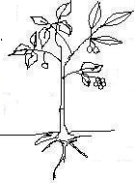

leaf fruit

flower

stem

roots

**Parts of a flowering plant.**

* It has 3 major namely leaves, stem , roots

**LEAF**

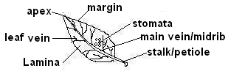

**Uses of leaves to plants**

* They make food for the plant.
* Some leaves store food
* They help plants during transpiration
* They are used for breathing

**PHOTOSYNTHESIS**

It is the process by which plants make their own food.

**Conditions necessary for photosynthesis**

* Chlorophyll (Green colour matter that trap sunlight)
* Carbon dioxide
* Water
* Sunlight (provide energy to plants)
* N.B Transpiration is the process by which plants lose water to the atmosphere through the leaves.

Raw materials for photosynthesis.

Water, carbon dioxide

Role of chlorophyll- traps sun light energy.

NB Photosynthesis does not take place at night because there is no sun light energy.

**Uses of leaves to animals.**

* Leaves are eaten bas food
* Leaves are used as herbal medicine
* Some plants have leaves used f or thatching houses
* They are used for decoration
* People sell leaves and get money.

**STEM**

**Types of stems**

1. Upright stems//erect stems



node

internode

**These types of stems are found in woody plants like**

* Mahogany
* Eucalyptus
* Ficus tree
* Mango tree
* Mvule

1. **Climbing stems**

They are also called weak/clasping stems.

**Examples of plants with climbing stems**

* Passion fruits
* Vanilla
* Some bean plants
* Water melon
* Pumpkin
* Some yams
* Cucumber

**How climbing plants climb others.**

* By twinning /clasping
* Using hooks or thorns
* Using tendrils

Plants using tendrils Plants using hooks by twinning

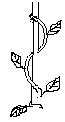

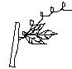

1. **Underground stems**

These are stems found below the ground e.g.

* Spear grass
* Couch grass
* Ginger

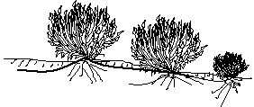

Adventitious roots

internodes

**USES OF STEMS**

1. To plants

* stems store food for the plants
* Transport and food
* Support branches and leaves
* Stems make plants to stand

1. **To animals**

* Stems are eaten as food
* Provide animals medicine
* Provides building materials
* We get timber/poles from woody plants

**Roots**

It is part of a flowering plant found under the ground.

**TYPES OF ROOTS**

**(a Tap roots**

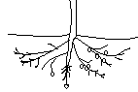

Main roots

Root hairs

Lateral root

Root cap

**N.B. Root cap**

- protects the growing tip of the root.

**Examples of plants with tap root system (legumes)**

* Beans
* Peas
* Soya
* Gnuts
* Sim sim

1. **Fibrous roots**

They are common in cereals/grains e.g. sorghum

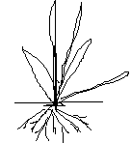

Fibrous roots

**Examples of plants with fibrous roots**

* Maize
* Sorghum
* Millet
* Wheat
* Rice
* Barley
* Oats
* Some grasses

1. Prop roots

They develop from the stem of the plant

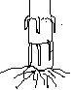

Prop roots

**Examples of plants with prop roots**

* Sorghum
* Maize
* Millet and some grasses

1. **Adventitious roots**
2. These also develop from the stem of the plant. They are common in plants like onions, some yams

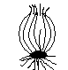

Adventitious roots

**Uses of roots to plants**

* Hold the plant firmly in the soil
* Absorb water and mineral salts from the soil
* Stores food for the plant

**Uses of roots to animals.**

* It is a source of food
* It is used as herbal; medicine
* Controls erosion like he buttress roots
* Some people sell roots and get money

**The flower**

A flower is the reproductive part of a plant.

**Uses of flowers to people.**

* They are used for decoration
* Bees and birds get nectar from flowers
* They are eaten as food
* They are used for making perfumes
* They are used for making colour
* They are used as herbal medicines

**Uses of flowers to plants**

* They help a plant to reproduce.

**SEEDS**

**A SEED is a developed ovule.**

**Uses of seeds**

* Seeds are eaten as food.
* Seeds are used for planting
* They are sold
* They are used as medicine
* They are used I making crafts
* They are used for making vegetable oil.

**Dangers of plants**

Some plants are poisonous e.g. Sodom apple to cattle

Some pare thorny and therefore damage the skins of animals.

Some plants harbor/hide dangerous animals and pests

Plants can be weeds hence compete for nutrients with crops.

Some water weeds cause suffocation of fish in the water.

**Clearing of land**

**Steps of clearing land**

-slashing: shortening of grasses or some bushes using a Slasher

- Digging /sloughing- breaking up of soil in preparation for planting

**Planting** : It is putting a planting material in the soil

* Seeds are selected for planting
* Afterwards seedlings are cared for.

**Methods of planting**

1. Broadcasting method: Is the planting of seeds by scattering them at random on land.
2. Row planting: Is he growing of plant material in lines.

**Caring for crops**

Weeding: The removal of unwanted plants room the garden.

Staking: giving extra support to plants with weak stems.

Pruning: Removal of excess branches from the plant.

Thinning: Removal of excess plants from the garden to create space.

Mulching: is the covering of different crops on the same piece of land seasonally.

Spraying: Application of chemicals on plants to control pests and diseases.

* Harvesting removal of ready crops from the garden during dry season.
* Drying harvested crops.

**Storing harvested crops**

Granaries Silos

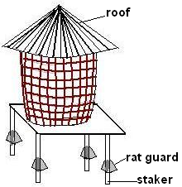

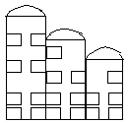

**Marketing**

It is the selling of crops

**Places of marketing**

* Markets
* Shop
* Vending

**PESTS AND DISEASES**

4 pest is an organism which destroys farmers’ crops.

**Examples**

* Monkey
* Rats
* Weevils
* Goat
* Birds
* Cows

**Pests control measures**

* Weeding
* Crop rotation
* Using scare crows
* Spraying using pesticides
* Row planting
* Early planting

Removing infected parts from the plant

Uprooting the plants which are severely attacked.

* Crop diseases
* Mosaic ,
* potato blight ,
* rust ,
* blast ,
* panama smut and rot

**Effects of diseases to plants.**

* They cause the crop to rot.
* Crops wither
* Crops dry out before time
* Fruits ripen prematurely
* Leaves fall off or become pale.
* Roots dry

**Disease control measures in crops.**

* Practice crop rotation
* Weeding
* Early planting
* Prune/remove the diseased parts
* Uproot the infected crops and burn them.
* Spray crops with medicine to control the diseases.

**GARDEN TOOLS**

|  |  |  |
| --- | --- | --- |
| Rake | * For collecting or gathering rubbish | * Keeping tools in a dry place. * By painting the tools. * By oiling garden tools * By greasing the tools. * By cleaning tools * Before storing them. |
| Watering can | * For watering crops |
| Forked hoe | * For digging hard soil and stony areas |
| Trowel | * For transplanting seedlings |
| hoe | * For digging * For weeding * Harvesting sweet potatoes, cassava, Irish potatoes,etc |
| panga | * For cutting down small trees. * For harvesting ready crops like bananas sugarcane,etc |
| Spade | * For carrying soil |
| Slasher | * For slashing |
| sickle | * For cutting grass |
| Pruner | * For pruning |
| Garden fork | * For turning manure |
| Wheel barrow | * For carrying soil * For carrying and transporting tools and harvested crops. |

**Seed germination**

Is he development of a seed into a seedling /a young plant?

A seedling is a young plant.

**Conditions necessary for germination.**

* Water , Oxygen, warmth (WOW)

**Types of germination**

* 1. Epigeal germination
* 2.Hypogeal germination

Hypogeal germination is where the cotyledons remains below the ground (in the soil).

It is common in cereals or monocots e.g. maize , millet , sorghum , rice , wheat , barley

**Diagram to show hypogeal germination.**



Level of soil

Cotyledon in the soil.

Epigeal germination is the type of germination where cotyledons come above the ground e.g. beans , groundnuts, simsim, mangoes, oranges, cow peas, apples, etc.

**Diagram to show epigeal germinal**

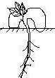

Cotyledons above the ground

**Note**: Plant a bean and maize to show the types of germination.

* Germination , burning , rusting and breathing (life) all use a common gas called oxygen.

An experiment to show the condition needed for germination.

**Things needed**

* 3 tins
* Cotton wool
* Seeds (beans , maize)
* Ice
* Oil

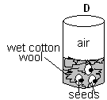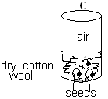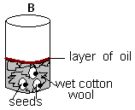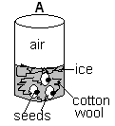

* In tin A he seeds will not germinate because there is no warmth.
* In in B, he seeds will not germinate because there is no air . The oil prevents air from entering to reach the seeds.
* In tin C, the seeds will not germinate because there is no water (moisture)
* In tin D, the seeds will germinate because there is air, water and warmth. The cotton provides warmth.

**-END-**

“ON A FIRM FOUNDATION WE BUILD”